Computer Organization & Architecture

15B11CI313

**Tutorial-5: Control Unit and ISA**

1. Consider the instruction formats of the basic computer shown in Fig. 3 and the list of instructions given in Table 1. For each of the following 16-bit instructions, give the equivalent four-digit hexadecimal code and explain in your own words what it is that the instruction is going to perform.

a. 0001 0000 0010 0100

b. 1011 0001 0010 0100

c. 0111 0000 0010 0000

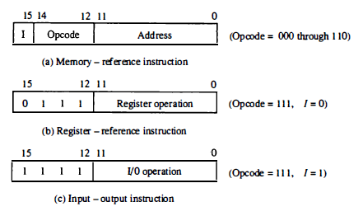

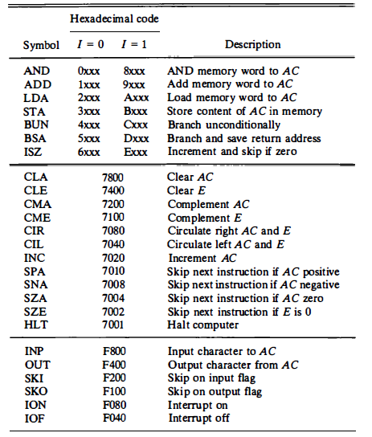

1. The system shown in Fig.2 uses a control memory of 1024 words of 32 bits each. The microinstruction has three fields as shown in the diagram. The microoperations field has 16 bits.
2. How many bits are there in the branch address field and the select field?
3. If there are 16 status bits in the system, how many bits of the branch logic are used to select a status bit?
4. How many bits are left to select an input for the multiplexers?

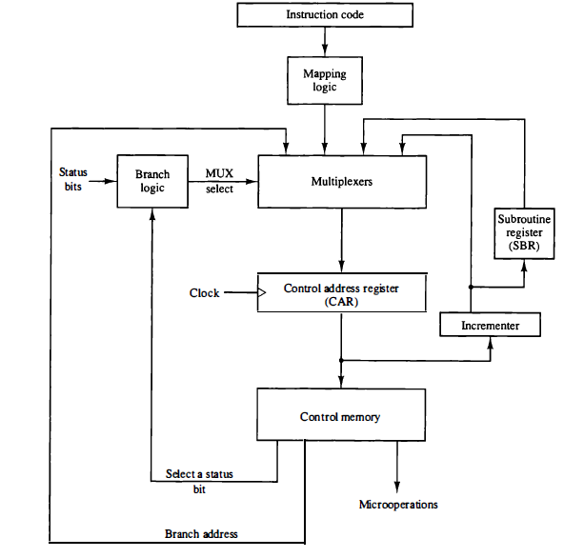

1. The microinstructions stored in the control memory of a processor have a width of 26 bits. Each microinstruction is divided into three fields: a micro-operation field of 13 bits, a next address field (X), and a MUX select field (Y). There are 8 status bits in the inputs of the MUX.

[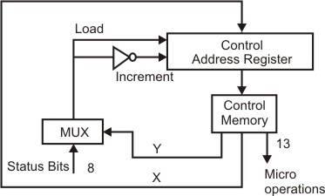](https://media.geeksforgeeks.org/wp-content/cdn-uploads/gq/2014/09/GATECS2004Q65.png)

How many bits are there in the X and Y fields, and what is the size of the control memory in number of words?

1. Consider a hypothetical Control Unit which supports 4 k words. The Hardware contains 64 control signals and 16 Flags. What is the size of control word used in bits and control memory in byte using:  
   a) Horizontal Programming  
   b) Vertical programming
2. If a Computer has 128 operation codes and 512 k addresses, how many bits would be required for
3. Single address instruction (ii) Two address instruction.
4. Represent the condition control statement by two register transfer statements with control functions.

If (P=1) then R1🡨 R2 else if (Q=1) then R1🡨R3

1. Write a program to evaluate the arithmetic statement



(i) Using an accumulator type computer with one address instruction.

(ii)Using a stack organized computer with zero-address instructions